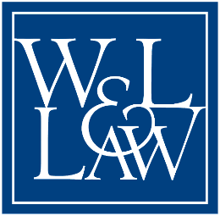
Washington and Lee University School of Law
Class of 1976 Law - 50th Reunion

Name: ___________________________________ Nickname: ________________________
Address: _____________________________________________________________________
City: _____________________ State: _______ Zip: _________ Country: _______________
Email: ____________________________________ Telephone: ________________________

Spouse/Partner Name: _________________________________________________________
City and state from which you came to W&L Law: ________________________________
Undergraduate School: ________________________________________________________

Influence of W&L Law on your life: _____________________________________________
____________________________________________________________________________
_____________________________________________________________________________

Influential Course or Professor: _________________________________________________
_____________________________________________________________________________

Favorite W&L Law memory: ___________________________________________________
______________________________________________________________________________
______________________________________________________________________________
______________________________________________________________________________

Brief Refection/Bio: ___________________________________________________________
_____________________________________________________________________________
_____________________________________________________________________________ _____________________________________________________________________________
_____________________________________________________________________________
_____________________________________________________________________________

Feel free to use the back of this page or an additional sheet.
Return to Sarah Hughes, Washington and Lee School of Law,
Sydney Lewis Hall #416, 204 West Washington Street, Lexington, VA 24450 or
email to: shughes@wlu.edu Questions? Call Sarah at (540) 458-7970

